2019 Annual Recognition Dinner
Register at: http://www.riograndecouncil.org/event/council-award-dinner/2449978
The Council Annual Recognition Committee invites you to an evening of fellowship and recognition on Saturday, March 2, 2019 at 6:30PM. Our Council Banquet is held annually to recognize the volunteers of the Rio Grande Council. The highlight of the evening is the presentation of the Silver Beaver Award and the Golden Beaver Award, the highest recognitions presented on the council level. In addition, other high level awards will be presented or recognized during the banquet.
Banquet includes:
- Order of the Arrow Awards & Vigil Honors
- 2018 Class of Eagle Scouts
- District Award of Merit
- Commissioner Key Award
- The “Spark Plug Awards”
- The Paisano Award
- Silver Beaver, Golden Beaver & James E. West Fellows Award Presentations

Saturday, March 2, 2019 - 6:30 pm
Camp Perry NEW dining Hall
FM 1420, Rio Hondo, TX 78583
Purchase an Individual Ticket for $20 at http://www.riograndecouncil.org/event/council-award-dinner/2449978
And Sponsor an Eagle - $20 Or Sponsor a table of 8 - $200
For more information please contact our Banquet Chair
Michelle Rodriguez at 956/212-7257 or email at rodriguezmichelle2000@yahoo.com
Cynthia Cardenas at 956-793-7868 or e-mail at cincard@aol.com
THE RIO GRANDE COUNCIL “THE SPARK PLUG AWARD” UNIT LEADER NOMINATION FORM
This nomination is confidential. To avoid possible disappointment, please do not advise the nominee or spouse in any way of your nomination. But please make sure you get the individual to attend the dinner.

Spark Plug Award – Due by February 9th, 2019 at eernest@bsamail.org
The Spark Plug award is presented to a Unit, District, or Council scouter who has made positive differences in a short amount of time. The Spark Plug exemplifies the Scout Oath and Law in their daily life and goes above and beyond the call of duty to spark the enthusiasm most in your unit: This is the person – who always helps (with a smile); makes one feel good by just being around them; picks one’s spirits up; and recharges one’s battery! They provide the required “spark” to keep things FUN, exciting, and moving.
Each unit in the district may submit nominations for the Spark Plug Award.
The Council Award Selection Committee may award one Spark Plug Award per unit.
The Spark Plug Award is also available to members of the Council/District Committee and Commissioner staff.
Requirements:
The Nominee must be a registered Adult Leader.
- The Nominee has made an important contribution to the success of the unit or district and has exemplified enthusiasm and determination.
- The Nominee has made an important contribution to the success of the unit or district and has exemplified enthusiasm and determination.
- The Nominee’s attitude and cooperation with the District and Council must be notable.
Nominee Personal Information:
Name: | Spouse:
Phone: | Street:
Email: | City, ST zip
Current Registered Position: | Unit # & Type
Noteworthy Service/Reason for Nomination (use additional paper if needed):
I certify that this nominee's character and behavior reflect the ideals of the Boy Scouts of America.
Name: | Current Registered Position:
Email: | Phone:

Rio Grande Council, BSA
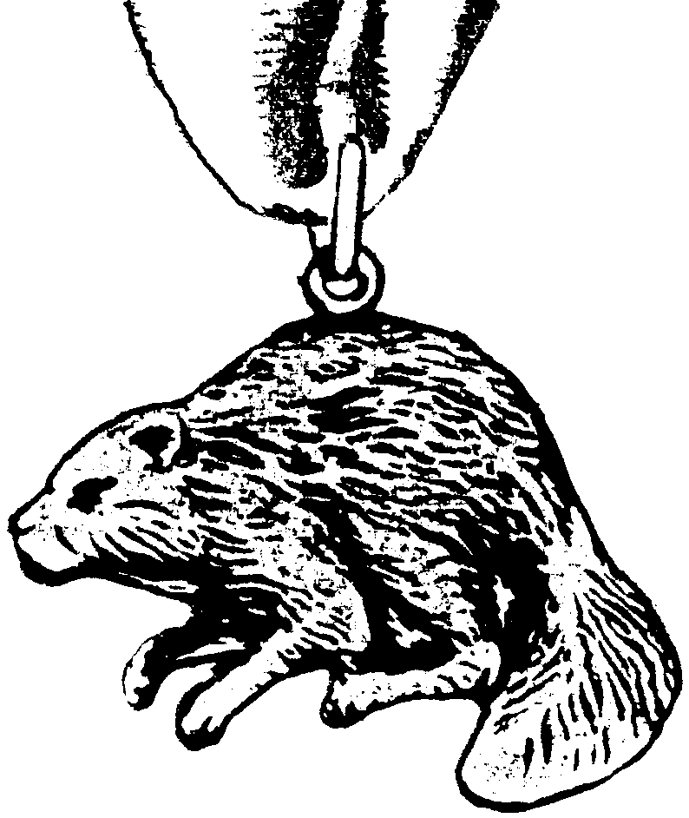

NOMINATION FOR THE SILVER BEAVER AWARD
(2018 Revised)

I take pleasure in presenting for consideration the nomination of the Scouter named below for the Silver Beaver Award:
Name
(Please provide full name, correctly spelled, and title, if any)
Address City/State/Zip
Home Telephone Work Telephone
Email Address

This Scouter is currently registered with Rio Grande Council as a and holds a
(List position in unit, district, or council)
Registration in District.
Family Background: Spouse’s Name
Were children in Scouting?
Business/Profession/Occupation and title:

Nominator’s Information:
Nominated by:
Position in Scouting District
Address City/State/Zip
Home Telephone Work Telephone
Email Address:

I. Mandatory Requirements:
A. Candidates for the award shall be registered volunteer Scouters within council territory.
B. They must be at least 21 years of age.
- They must have rendered noteworthy service of exceptional character to youth. It is recognized that the nature and value of noteworthy service to youth might take the form of a single action which contributed to the lives of large numbers of youth or that the service might be given to a small group over an extended period of time.
- Nominations may NOT be considered for former professional Scouters or council employees or Scout Shop employees within five (5) years of their leaving employment with the BSA or National Supply Division. (i.e.: secretary, ranger, professional executive, manager, or any other form of temporary or full-time employee.)
- Nominations cannot be made for posthumous awards.
- The council is limited in the number of Silver Beaver awards it can present each year and this is based on total units in a council and NOT number of districts. This is not a district award.
- Nominations are due on or before January 17, 2019, to the Rio Grande Council, BSA, 6912 W Expressway 83, Harlingen, TX 78552 or P.O. Box 2424, 78551-2424. Nominations received after this date will not be accepted.

II. Desirable Requirements:
A. Ten years of service to youth in Scouting.
B. Candidates should have some experience in service to youth outside of Scouting.
C. Their service should be regarded as outstanding or distinctive beyond the expectation of normal duty.
D. The nominee has an exemplary record of service, reputation, and standing in the community.

III. Nomination Preparation Instructions:
- Read all of this nomination form carefully before attempting to fill it out. This is a job that requires research and should not be done hurriedly or in an offhand manner. You may wish to call on others who know your candidate for help in gathering the facts. This includes talking to his/her family.
- This nomination form is CONFIDENTIAL. To avoid possible disappointment, please do not advise the nominee in any way of your action on his/her behalf.
- Typed nominations are highly recommended as they reproduce better and can be more easily reviewed by the Selections Committee.
- Remember that the council is limited in the number of Silver Beaver Awards it can confer in a calendar year. It is not uncommon for nomination forms to be updated and resubmitted for consideration the next year.

Rio Grande Council / BSA Page 2

Nominee Information

- Please list ONLY REGISTERED ADULT POSITIONS in the Boy Scouts of America with dates and offices held listed chronologically. (Indicate Unit numbers and names of districts where appropriate.)

Unit Positions:
CR Chartered Organization Rep
CC Committee Chair
MC Committee Member
CM Cubmaster
CA Assistant Cubmaster
DL Den Leader
DA Assistant Den Leader
WL Webelos Den Leader
WA Asst Webelos Den Leader
DC Den Leader Coach
TC Tiger Cub Coach/Coordinator
SM Scoutmaster
SA Assistant Scoutmaster
NL Crew Advisor
NA Assistant Crew Advisor
VC Varsity Coach
VA Assistant Varsity Coach
SK Skipper
MT Mate
District Positions:
District Chair
District Committee Member
Member at Large
District Commissioner
Assistant District Commissioner
Unit Commissioner
CS Roundtable Commissioner
CS Roundtable Staff
BS Roundtable Commissioner
BS Roundtable Staff
Merit Badge Counselor
Council Positions:
Council President
Council Commissioner
Council Executive Board
Member at Large
Council Committee Chair
Council Committee Member
Honorary Life Member

Unit Types:
Cub Scout Pack
Boy Scout Troop
Venturing Crew
Varsity Team
Ship
District
Council

Positions Year(s) Total Unit Type and Number District
_________________________________________________________________________________________________
___________________________________________________________________________________________________________________________________________________________________________________________________________________________________________________________________________________________________

Total number of years as an adult volunteer:

- Record of noteworthy service on a DISTRICT and/or COUNCIL level to youth within the territory under the jurisdiction of this council. List here any ACTIVITIES or TRAINING EVENTS where the nominee held a chair or staff position.

District Positions Held Event Date
__
__
__

Council Positions Held

Rio Grande Council / BSA Page 3 Silver Beaver Nomination Form

C. Awards or recognition received as an adult volunteer in Cub Scouting, Boy Scouting, or Venturing:

CUB SCOUTS
- Cubmaster Award
- Cub Scouter Award
- Den Leader Award
- Webelos Den Leader Award
- Den Leader Coach Award
- Tiger Cub Coach Award

BOY SCOUTS
- Scouter’s Training Award
- Boy Scout Leader Training Award
- Scoutmaster’s Key
- Scoutmaster Award of Merit
- Varsity Scout Leader Training Award
- Varsity Scout Coach’s Key

VENTURING
- Venture Leader Training Award
- Crew Advisor Award of Merit
- Crew Advisor of the Year
- Assist. Crew Advisor of the Year Award
- Adult Leadership Award

DISTRICT COMMITTEE
- District Committee Key

COMMISSIONER SERVICE
- Scouter’s Key-Unit Commissioner
- Scouter’s Key-ADC
- Scouter’s Key-District Commissioner
- Scouter’s Key-CS RT Commissioner
- Scouter’s Key-BS RT Commissioner
- Arrow Head Honor
- Distinguished Commissioner Service Award

OTHER
- District Award of Merit
- Adult Religious Emblem
(Please indicate which one)

- James E. West Fellowship
- Order of the Arrow Ordeal
- Order of the Arrow Brotherhood
- Order of the Arrow Vigil
Wood Badge – 2 beads
- Wood Badge – 3 beads
- Wood Badge – 4 beads

COUNCIL OPERATING COMMITTEES
- Award of Excellence- Year(s)
Advancement
Growth
Cub Scout Training
Boy Scout Training
Public Relations
Activities
District Operations
Unit Commissioner
Asst. Dist Commissioner
District Commissioner
Cub Scout Roundtable
Boy Scout Roundtable

List any DISTRICT specific recognition or awards not listed above:

List any COUNCIL specific recognition or awards not listed above:

D. Information covering the nominee's standing in the community, citing activities in which he/she is MOST ACTIVE in business, professional, civic, religious, educational, fraternal, veterans, and other fields, exclusive of Scouting.
Please list organization, position held, and year(s) involved.
Organization Position Year(s)

List any additional noteworthy community service not noted above:

Rio Grande Council / BSA Page 4 Silver Beaver Nomination Form

E. Give specific and detailed examples of why you consider this person to be a good role model and how their work in Scouting has impacted youth. This section MUST BE COMPLETED to determine worthiness of candidate. (You may attach one additional page if needed.)

NOTE: This nomination is confidential. To avoid possible disappointment, please do not advise nominee in any way of your action on his/her behalf. For more information, contact your District Advancement Chair.

Nominations are due on January 17, 2019.
ONLY CURRENT NOMINATION FORMS WILL BE ACCEPTED.

Send nominations to:

Silver Beaver Selections Committee
Rio Grande Council / BSA
6912 W. Expressway 83
Harlingen, Texas 78552

Or P.O. Box 2424 Harlingen, Texas 78551-2424
Or EMAIL ernest.espinoza@scouting.org

Late nominations cannot be accepted.

