Rio Grande Council Boy Scouts of America *Proudly Presents*

Winter Camp 2022



Back & Better Than Ever…..

Camp Charles F. Perry

December 26-30, 2022

**Rio Grande Council, Boy Scouts of America**

*6912 W. Expressway 83,*

*Post Office Box 2424,*

*Harlingen, TX 78551-2424*

*(956) 423-0250 (956) 421-4950 fax*

Dear Scouter,

The number of Scouts achieving the Eagle rank has increased dramatically since the Rio Grande Council added Winter Camp to its rich tradition of quality programs. Scouters who have participated in past Winter Camps can feel proud of having been a part of this great achievement. We can’t emphasize enough what a great opportunity Winter Camp represents toward keeping our scouts on their Trail to Eagle all at an affordable price.

This year we celebrate our 28th Winter Camp and 113 years of Scouting!!! On behalf of the Rio Grande Council and the Winter Camp Committee we would like to extend a cordial invitation to all troops and a big thanks to all who have contributed with their time and effort to make Winter Camp the great experience it is. Last year’s Winter Camp was a success, and we are looking forward to a **ANOTHER Great Winter Camp Again.**.

This year’s Winter Camp features the same 4-day process. **All classes will be held at Camp Perry and start at 4:00 pm on Monday, December 26, 2022 and we’re ending camp on Friday, December 30, 2022 with a 5:00 pm departure(or earlier) time allowing everyone to make it home in time for the New Year’s Eve celebration**. All classes will continue to be taught at Camp Perry, so no additional driving is necessary. In addition, we’ve added a new Facility, which houses a New Office, Trading Post. Health Center, Training Rooms and an Indoor gym. Additional restrooms have also been added. Face Coverings or Masks will be optionl. COVID-19 Safety Precautions will be determined and you will be updated.

Please read this Leaders’ Guide thoroughly, since changes have been made. Troops attending should register as soon as possible since class space is limited. ALL SCOUT LEADERS NEED TO COMPLETE THE ADULT LEADER PARTICIPATION APPLICATION BY THURSDAY DECEMBER 15, 2022. PLEASE FAX TO THE SCOUT OFFICE…956-421-4950

Winter Camp is an All-Volunteer run camp, in the Rio Grande Council. With the assistance of qualified adult leaders and merit badge counselors, we can offer a quality program with counselors that have the required expertise for the subjects they are teaching. **If you would like to teach a merit badge or have any ideas how to enhance the program, please let us know as soon as possible via the e-mails listed below.** **Contact Oscar Garza at (956)624-7610 or email him at** [cholrep@yahoo.com](mailto:cholrep@yahoo.com) **if you want to be a Winter Camp Volunteer**. We want to hear from all of you. Registered troops will be notified of any changes to the program. An updated Merit Badge Schedule will be posted to the website with available course offerings as we get closer to the event.

We hope this information will be helpful and we look forward to seeing you and your troop at the Winter Camp 2022.

Yours in Scouting,

*Oscar R. Garza*

Winter Camp Director

cholrep@yahoo.com

956-624-7610

*Rudy Gonzalez*

Scout Executive**rudy.gonzalez@scouting.org**

956-423-0250

**PLEASE NOTE: Due to changes in the Criminal Background requirements your cooperation with the process is mandatory. All youth protection requirements are a must. Pages 19 & 20 of this manual need to be signed and sent/emailed to Harlingen Scout Office prior to Saturday December 15, 2022. Please provide Scout Roster and complete/bring Scout Checklist upon arrival/check-in.**

**GENERAL INFORMATION**

**PURPOSE**

The purpose of Winter Camp is to provide a learning environment where Scouts can work on earning Eagle required merit badges along with others not normally offered at summer camp. All merit badge classes are taught by adult volunteer leaders; many who are experts in the subject matter they are teaching. Evening programs and other special events complete the Winter Camp experience.

**WHEN AND WHERE**

The Rio Grande Council’s Winter Camp will be held at:

**Camp Perry**: 2 mi. North FM 1420

P.O. Box 956

Rio Hondo, TX 78583

(See map on page 17)

**(FOR INFORMATION, CALL THE COUNCIL OFFICE AT 956-423-0250)**

**Date:** Monday December 26, 2022 to Friday December 30, 2022

**Arrival Time:** Between 11:30 am and 1:30 p.m., Monday, December 26, 2022

**Departure Time:** 5:00 pm(Or Earlier) Friday, December 30, 2022

**\*Those troops wanting to stay the 5th night to accomplish the 5-night camping requirement for a Long-Term Campout for OA can stay the extra night. Please notify Oscar Garza (956)624-7610….NO BREAKFAST WILL BE SERVED ON DECEMBER 31, 2022! Facial Coverings or Masks will be optional. COVID-19 Safety Precautionsare being discussed, further information will follow.**

**\* To accommodate Troops who will be traveling long distances, special basic camping arrangements can be made for those needing to stay an extra night. Please notify Oscar Garza by email,** [**cholrep@yahoo.com**](mailto:cholrep@yahoo.com) **prior to arriving. NO BREAKFAST WILL BE SERVED ON DECEMBER 31, 2022!**

**WHO ATTENDS**

Winter Camp is intended for all Scouts. In order to ensure that every Scout has a good experience, Scoutmasters need to work with each scout to make sure that they are eligible for the classes they sign up for***.*** A scout’s emotional and physical maturity should be considered when certain merit badges are of interest.

All Scouts who attend **must** be registered members of the Boy Scouts of America.

Maverick Scouts are welcomed and encouraged to attend. There is NO EXTRA CHARGE FOR MAVERICK SCOUTS. Camping arrangements will be made upon arrival.

**ADMINISTRATIVE INFORMATION**

**CHECK-IN AND CHECK-OUT**

Camp personnel will be checking in Troops between **11:30 am and 1:30 p.m. on Monday December 26, 2022**. Please plan your arrival at Camp Perry as close as possible to check-in on time.Anyone arriving early needs to have adult supervision in the parking lot until the check-in process begins. Any maverick scouts should be accompanied by an adult until the scout is checked in and given a campsite assignment.

Departure is scheduled for **Friday**, **December 30,2022 at 5:00 pm(or earlier).**

Leaders, Scouts and guests arriving/leaving camp during the week must stop at the camp office and sign in/out. Wrist Bands will be provided for everyone. Any changes to campsite adult leader contact information must be provided to the Camp Director when it occurs.

**COST**

**$ 240.00 per Scout before December 20, 2022 / midnight deadline**

**$ 120.00 per Adult before December 20, 2022 midnight deadline**

***(Fee includes all meals, a Winter Camp Item and Patch)***

* After December 23, 2022, a $55 Administrative Late Fee will be imposed on all registrations.
* No adults will be allowed into camp without a cleared Criminal Background Check conducted by the Rio Grande Council. **(December 15, 2022).**
* No Walk-in Registrations will be accepted.
* All fees must be paid on-line prior to the start of camp.

All registrations are handled online <https://riograndecouncil.doubleknot.com/event/winter-camp-2021/2860932>

**Please have only one person per troop handle the registration process to avoid duplication of registrations and other common problems.**

**PHYSICAL EXAMS AND HEALTH SERVICE AT CAMP**

Each Scout and adult who attends camp must bring a properly filled out and signed ***Annual BSA and Medical Record*** Form 680-001, available at <https://www.scouting.org/health-and-safety/ahmr/> Please make sure copies of all medical forms are kept by the parents or the Scoutmaster. Everyone attending camp will receive a medical re-check upon arrival as part of the check-in procedure. Medical forms will be returned at check-out time.

All medications brought to camp will be kept in the Health Lodge. No medications will be kept in campsites, other than those approved by the Camp Health Officer. Medication will be checked in with the Health Officer, who will see that medications are made available to campers at the prescribed times. Be sure that medications are clearly labeled with camper’s name and troop number on each container.

**MEALS**

All meals will be served in the dining hall. The first meal of camp will be dinner on Monday December 26, 2022. The last meal will be Lunch with a scheduled a 5:00 pm(or earlier) Departure on Friday December 30, 2022.

**Any dietary restrictions or requests must be requested by December 15, 2022on the registration and please contact Oscar R. Garza directly for any special food requests at (956) 624-7610 or cholrep@yahoo.com.**

**TENTAGE AND CAMPING EQUIPMENT**

Troops are expected to furnish their own tents and camping equipment.

**TRADING POST**

The Camp Trading Post will be open to serve you. Items such as candy, soft drinks, and sundry items will be available. Various handicraft items will be offered along with T-shirts, mugs, patches and literature including some merit badge pamphlets and worksheets for the merit badges being offered in the Winter Camp Program.

**CAMP TELEPHONE**

There is a business telephone at camp for Camp purposes and emergencies. Oscar Garza(The Camp Director) cell number is (956) 624-7610.

**MAIL SERVICE**

Mail should be addressed in the following manner:

[Name of Camper] Troop [Number]

CAMP PERRY

P.O. BOX 2424

Harlingen, TX 78551

**CAMP STAFF**

The Winter Camp staff is providing a top-quality program. Anyone interested in teaching a merit badge class or helping out in another capacity can contact the Winter Camp Director, Oscar Garza at [cholrep@yahoo.com](mailto:cholrep@yahoo.com) or call him at (956)624-7610 to volunteer **ASAP**. I also need some to run the Trading Post. All volunteer instructors must be State of Texas Youth Protection Certified, have a Criminal Background Check for 2022 performed through our system, and be a registered adult leader. A State of Texas Youth Protection Training will be offered in late November or early December. It will be posted on the council calendar and we will send out email communications.

**PETS**

**No pets** *of any type* will be permitted in camp.

**FIREARMS, AMMUNITION AND FIREWORKS**

**Personal firearms, ammunition, archery equipment and fireworks** of any kind are not permitted in camp at any time for any reason. This applies to all campers, volunteers, adult leaders and camp staff without exception.

**ALCOHOLIC BEVERAGES AND DRUGS**

No alcoholic beverages of any kind are permitted on Rio Grande Council, B.S.A. properties. There are no exceptions to this policy!

The possession or consumption of any form of controlled drugs or narcotics, not under the prescription of a physician licensed to practice medicine, is strictly prohibited on any property of the Rio Grande Council, B. S .A. Violators will be asked to leave camp immediately.

**HAZING/BULLYING**

Hazing, bullying or initiation of any form is considered child/peer abuse and will not be tolerated anywhere under the auspices of the Boy Scouts of America.

**LIVING TREES**

Camp Perry is a showcase of native trees and shrubs of South Texas. Please do not cut live trees and shrubs without permission from the Camp Ranger/Director.

**CANDLES**

Absolutely no candles, flames or open fires of any kind may be used in tents. Only battery lanterns are permitted in tents.

**LEADERS’ MEETING**

**There will be an adult leaders’ meeting the first afternoon Monday Dec. 26, 2022 at 2:30 pm in the Dining Hall because classes will begin at 4:00 pm**. **An SPL meeting will take place at 3:00 pm in the Dining Hall**. All adults are required to attend the meeting, keeping in mind that scouts should not be left without any adult supervision. Additional rules and guidelines not listed in this Leaders’ Guide will be covered. Class rosters will be passed out to those who have volunteered to teach Merit Badge classes. While every effort is made to keep this to a minimum, there may be some classes without assigned merit badge counselors. At that time we will ask for volunteers to teach these classes. Volunteer merit badge counselors should come prepared to teach the basic requirements of their assigned classes. Any last minute volunteers will have usage of the office computer and other resources as needed in order to prepare for their classes. Other leaders’ and/or SPL meetings will be scheduled as needed. **All those adult leaders need current Texas YPT.**

**NO CLOSING CAMPFIRE**

This will be determined

**EMERGENCY PROCEDURES**

**General Emergency Procedures:**

1. Report all emergency situations (fires, accidents, etc.) to the nearest Staff member.
2. The Staff member will report directly to the Camp Director, Program Director, or the Camp Ranger.
3. If the situation is evaluated as a CAMP-WIDE EMERGENCY, the bell near the Parade Ground will be rung and the camp sirens will be sounded to alert all persons in camp.
4. **On hearing the bell and sirens:**
   1. All Staff members will gather at the flagpole on the parade ground.
   2. All Scoutmasters, troop leaders, and Scouts will report to the flagpole in the center of the parade ground.
   3. Emergency instructions will be given at the flagpole.
5. **Fire:**
   1. Campsite: (Remember to bring a water hose to camp).
      1. Drop all canvas immediately after checking whether tents are occupied.
      2. Notify Camp Director, Program Director, or Camp Ranger immediately.
      3. Use water buckets to extinguish fire.
      4. If help is needed, a camp-wide emergency will be signaled.
6. **Building:**
   1. Evacuate building immediately.
   2. Notify Camp Director or Camp Ranger immediately.
   3. Stay away from buildings until given further directions by the Camp Director or Camp Ranger.
7. **On Camp property (brush or grass):**
   1. Contact any campsite in path of fire to evacuate site.
   2. Notify Camp Director or Camp Ranger immediately.
   3. A Camp-wide Emergency will be signaled.

**Lost Camper:**

In the event a camper is reported lost, immediately send someone to notify the Camp Director. At the same time, send a Staff member or a reliable camper to the missing camper’s campsite, his scheduled activity area for that period as well as any other likely place to determine the accuracy of this report. After these reports have returned negative, and other likely spots have been searched and the Camp Director or his representative has determined that the missing camper will not be found easily, the alarm will be sounded for a Camp-wide Emergency.

If the assembly shows the camper to still be missing, consult with anyone who might have additional knowledge of his whereabouts and send additional searchers to those locations. Additional steps to be taken in sequence are: Arroyo bank search and camp-wide search until missing camper is found or the authorities are notified.

**CURRICULUM INFORMATION**

**SELECTING MERIT BADGES**

The Scoutmaster should counsel each Scout to determine which merit badges he should select and identify any requirements of those selections he should complete prior to Winter Camp in order to insure completion at camp. Most of the Eagle required Merit Badges require extra time. Some cannot be completed until after the Scout fulfills requirements following Winter Camp. Be sure your Scouts have enough free time to keep up with their studies and still have time for some fun. Our counselors will only sign off on completed merit badges when the merit badges are earned. In some cases, partials cannot be avoided.

**ATTENDANCE**

Attendance at Merit Badge instruction sessions, and projects associated with them, is necessary to complete the badges. If a Scout finds it necessary to miss a session for valid reasons, he should work with the instructor to compensate for the lost time.

**INSTRUCTORS\***

Scouters teaching a merit badge should be registered as merit badge counselors using BSA Adult Application <http://www.scouting.org/filestore/pdf/524-501.pdf> and BSA Merit Badge Counselor form #34405 available at [www.scouting.org/filestore/pdf/34405.pdf](http://www.scouting.org/filestore/pdf/34405.pdf). This form can be brought to camp or completed at camp. During the fall months, adult leaders will be recruited to teach specific merit badges with ample time to prepare for the classes. Merit Badge instructors should thoroughly read the respective merit badge pamphlets and peruse websites like [www.meritbadge.org](http://www.meritbadge.org) to make use of available resources. **At the leaders meeting on Monday December 26, 2022 at 2:30 pm, some adults may be asked to volunteer to teach a merit badge class if a specific class has not been assigned to a recruited volunteer prior to camp.**

**\*ALL instructors are required to meet the youth protection training standards for BSA. Training is available online on myBSA.org. and this may be taken at any time.**

**UNIFORMS**

Please be in full official Scout uniform (all Scouts and adult leaders) for only Evening Flag Ceremonies and each evening meal. Activity shirts, i.e. Winter Camp T-Shirt, may be worn all other times.

**SCHEDULE**

Enclosed in this Leaders’ Guide is a Daily Schedule for Winter Camp. Note there are five (5) periods of instruction. This means each Scout can expect to take a maximum of 4, 5, 6 or 7 Merit Badges. An updated daily schedule will be available at camp each morning.

**STUDY HALL**

Study Hall is to be held at each Units’s campsite for Scouts to study, write reports, and prepare for classes. Lights Out at 11:00 pm each night.

**FOR NEW SCOUTS LOOKING FOR THE FIRST-CLASS RANK**

Camp Perry Winter Camp will offer “Path To First Class,” for 2 hours each day. This should assist in jump starting those Scouts needing the Rank Advancement. It also allows the Scout to take at least 2-4 Eagle required classes as well. The “Path To First Class” is open to any scout needing assistance in gaining the First Class Merit Badge.

**BLUE MERIT BADGE APPLICATION CARDS AND SUPPLIES**

No Blue Cards are required for Winter Camp. All records will be available to unit leaders after Camp.

**MERIT BADGE HANDBOOKS & WORKSHEETS**

All merit badge booklets need to be purchased in advance at the Scout Office in Harlingen, Texas. Some booklets may be available at the camp. Please note that the Rio Grande Council store is closed for inventory in late December and will not be open during the week of Winter Camp. Be Prepared and make your purchases early. **Scouts should be prepared for their classes and bring Merit Badge worksheets with them to camp.** No Merit badge worksheets will be available at camp. <https://meritbadge.org/wiki/index.php/Merit_Badge_Worksheets> is the link for the Merit Badge Worksheets.

**PREREQUISITES**

Review the merit badge prerequisites on page 11. Please be sure Scouts do the prerequisites listed prior to Winter Camp. ***We want to minimize partials!***

**REGISTRATION FOR MERITBADGE COURSES**

**Registration for Merit Badges should take place prior to your arrival at camp**. Upon check in at camp, copies of each Scout’s Daily Schedule will be given to his Scoutmaster. A copy will be maintained in the camp office. Any last minute changes will take place after the first 2:30 pm Monday Dec. 26, 2022 Scoutmaster Meeting in the office. If it becomes necessary to limit classes, higher rank Scouts will be given preference on all Eagle required merit badge offerings.

**ORDER OF THE ARROW SOCIAL**

The Order of the Arrow will not be hosting a social this winter camp.

**EVALUATIONS**

**All adult leaders & some scouts will be asked to evaluate the program during the week and submit their evaluations at the end of camp before they leave.**

**POSSIBLE**MERIT BADGES & SPECIAL PROGRAMS**

**(PLEASE FOLLOW THE ATTACHED CLASS SCHEDULE TO REGISTER FOR THE OFFERED MERIT BADGES)**

**MERIT BADGES (Eagle Required)**

CAMPING EMERGENCY PREPAREDNESS CITIZENSHIP IN THE COMMUNITY ENVIRONMENTAL SCIENCE CITIZENSHIP IN THE NATION FIRST AID

CITIZENSHIP IN THE WORLD PERSONAL FITNESS

COMMUNICATIONS PERSONAL MANAGEMENT

COOKING SUSTAINABILITY

**MERIT BADGES (other)**

|  |  |
| --- | --- |
| AMERICAN BUSINESS | LAW |
| ANIMAL SCIENCE | MEDICINE |
| ARCHITECTURE | MUSIC |
| ASTRONOMY  AUTOMOTIVE MAINTENANCE | NUCLEAR SCIENCE  ARCHERY |
| AVIATION |  |
| BACKPACKING****** | ORIENTEERING |
| BUGLING | PHOTOGRAPHY |
| DIGITAL TECHNOLOGY | PLANT SCIENCE |
| CRIME PREVENTION | PLUMBING |
| DENTISTRY | PUBLIC SPEAKING*** |
| DISABILITIES AWARENESS | RADIO |
| DOG CARE  WILDERNESS SURVIVAL | RIFLE SHOOTING (BLACK POWDER |
| ELECTRICITY | SALESMANSHIP |
| ELECTRONICS***** | SHOTGUN SHOOTING |
| ENGINEERING | SOIL&WATER CONSERVATION* |
| FINGERPRINTING****  FISHING | SPORTS |
| FISH & WILDLIFE MANAGEMENT* | TRAFFIC SAFETY |
| SCHOLARSHIP |  |
| GEOLOGY |  |
| HOME REPAIR | WEATHER  WELDING |
| INSECT STUDY | WOODWORK |

*One required for World Conservation Award along with Citizenship in the World and Environmental Science

**Complements the Citizenship Merit Badges

***Complements Communications Merit Badge

**** Complements Crime Prevention Merit Badge

*****Complements Electricity Merit Badge

****** Complements Camping Merit Badge

The final listing of merit badges and special programs is contingent on demand and availability of qualified instructors. Please see attached Class Schedule to register. An updated listing of Merit Badges and other special programs will be available on the council website when the course offerings are finalized and available for reservation. Please check for updates. Additional Merit Badges not on this list may be added! Some of these Merit Badges may not be offered also.

**SPECIAL PROGRAMS**

**(May be Offered/Update To Follow)**

|  |  |
| --- | --- |
| BRANDING | PAUL BUNYAN AWARD |
| CAMP RELAY | PIONEERING COMPETITION |
| CAMP SERVICE PROJECTS | PRIDE IN PERRY AWARD |
| DUTCH OVEN COMPETITION | TOTIN CHIP |
| FIRE ‘EM CHIT | TROOP SPIRIT AWARD |
| HUNTER’S SAFETY COURSE* | TUG OF WAR |
| LEAVE NO TRACE  BMX Age Requirements* Followed | SHOT GUN COMPETITION |

*Note: There is a $20 fee for Hunter’s Safety. Deadline to register for this course is Nov. 30th in order to order materials needed for the class. Special programs are subject to change depending on instructors.

**MERIT BADGE PREREQUISITES/ADDITIONAL INFORMATION**

The merit badges listed on this page have requirements that cannot be done at camp and should be completed **before** arriving at camp. Others listed have additional information of which Scouts should be aware before they are registered for the class. Scouts should come prepared with their own classroom supplies: pens, pencil, paper, binders, markers, etc.

**EAGLE REQUIRED BADGES:**

**Citizenship in the Community Personal Management\*\*\***

**7 1, 2, 8**

**Citizenship in the Nation Personal Fitness**

**8** ` **8**

\*\*\***RECOMMENED FOR SCOUTS 14 YEARS & OLDER**

**OPTIONAL BADGES**

Crime Prevention Music

**4b 3c** (if selected)

Electricity Dog Care

**2, 8 4**

Fish and Wildlife Management Backpacking

**5a, 5b, 5b** (if selected) (taught with Camping MB; bring backpack for

**6c** (if selected) overnight hike)

**7b, 7d** (if selected)

Sports

**4**

**(Please research other Merit Badges for prerequisite requirements as this list is not all inclusive.)**

**DAILY SCHEDULE**

**FLAG 6:45 A.M. TO 7:00**

**BREAKFAST 7:00 A.M. TO 7:45 A.M MERIT BADGE**

CLASS 1 8:15 A.M. TO 9:45 AM

CLASS 2 10:00.M. TO 11:30 A.M.

**LUNCH 11:45A.M. TO 12:45 P.M.**

CLASS 3 1:15 P.M. TO 2:45 P.M.

CLASS 4 3:00 P.M. TO 4:30 P.M.

SPECIAL PROGRAMS 4:30 P.M TO 5:30 P.M. ________________

**FLAG/SUPPER 5:30 P.M. TO 6:45 P.M.**

CLASS 5 7:00 P.M. TO 8:30 P.M.

**STUDY HALL** */* **CRACKER BARREL 8:30 P.M. TO 9:45 P.M.**

**PLEASE NOTE: THE FIRST CLASS ON THE FIRST DAY OF CAMP MONDAY DECEMBER 26, 2022 IS AT 4:00 PM (THE USUAL 3:00 PM CLASS) AND 7:00 PM CLASS AND THE LAST DAY OF CLASSES, FRIDAY DECEMBER 30, 2022, ENDS AFTER 3RD PERIOD…DEPATURE IS AT 5:00 PM(OR EARLIER) ON LAST DAY.**

***WHAT TO BRING TO WINTER CAMP***

***CLOTHING***

Complete Scout Uniform (shirt, belt, pants or shorts, scout socks) SweatshirtUnderwear SweatpantsShorts

JacketSturdy, Well Broken-in Hiking Boots

Rain GearSneakers

Hat ***/*** CapSocks

Blue JeansTowels & Washcloths

***TOILETRIES***

Toothbrush

Toothpastes

Soap & Soap Dish

Shampoo

Deodorant

Comb or Brush

Shaving Gear (if regularly used)

***EQUIPMENT***

Back Pack or Duffel Bag

Flashlight

Personal First Aid Kit

Pocket Knife (No Sheath Knives Allowed) Sunglasses (if worn)

Drinking Cup

Sleeping Bag (or several blankets) Plastic Ground Cloth, Cot

Or Foam Sleeping Pad

Pillow

Clothesline and pins

Wrist Watch

Travel Alarm Clock

***SCHOOL SUPPLIES***

Paper (lined loose leaf to turn in reports) Binder (to organize materials)

Pencils

Pens

Markers (for marking posters, books, etc.)

**REMEMBER: A SCOUT IS PREPARED.**

Don’t let your Winter Camp experience be uncomfortable because you didn’t pack the right stuff! *ABSOLUTELY* be prepared for cold and/or wet weather. If you have any doubt about what to bring, ask someone who’s been to camp before.

***OTHER NECESSITIES***

BSA Handbook

Spending money (suggest $ 50.00)

Prescription Medications with instructions (if taken)

**PLEASE NOTE: Due to changes in the Criminal Background requirements your cooperation with the process is mandatory. All youth protection requirements are a must. See pages 19-21 of this manual for details.**

**UNIT ROSTER**

TROOP ___ COUNCIL __________________CAMPSITE :____________________

TOTAL YOUTH: ___________________TOTAL ADULTS:

**LEADERS IN CAMP**

SCOUTMASTER: ADDRESS CITY, STATE, ZIP PHONE NUMBERS E-MAIL ADDRESS

ASST. SCOUTMASTER:

OTHER LEADERS:

**SCOUTS IN CAMP**

SENIOR PATROL LEADER:

|  |  |
| --- | --- |
| PATROL NAME | PATROL NAME |
| 1. | 1. |
| 2. | 2. |
| 3. | 3. |
| 4. | 4. |
| 5. | 5. |
| 6. | 6. |
| 7. | 7. |
| 8. | 8. |

**(PLEASE HAVE THIS ROSTER COMPLETE PRIOR TO CHECK-IN. PLAN TO TURN IT IN AT THE CAMP OFFICE UPON ARRIVAL, ALONG WITH ANY OUTSTANDIING FEES DUE).**

**UNIT ROSTER**

|  |  |
| --- | --- |
| **PATROL NAME:** | **PATROL NAME:** |
| 1. PL | 1. PL |
| 2. | 2. |
| 3. | 3. |
| 4. | 4. |
| 5. | 5. |
| 6. | 6. |
| 7. | 7. |
| 8. | 8. |

**PLEASE COMPLETE FORM (BOTH SHEETS) AND BRING TO CAMP AT CHECK-IN.**



**PLEASE NOTE: Due to changes in the Criminal Background requirements your cooperation with the process is mandatory. All youth protection requirements are a must. See pages 19 & 20 of this manual for details.**

**Check-in Checklist**

**Troop #**

This checklist is to be filled out and turned in at check-in (Dec 26) by the Troop

Scoutmaster or other designated adult leader along with the documents listed below:

**For each Troop,**

□ Winter Camp 2022 Unit Rosters (with this package)

Proof of council insurance (for out of council troops)

**For each Scout, (Number of Scouts = )**

□ Annual BSA Health and Medical Record form

□ If applicable, list of medicines taken and schedule

**For each Adult, (Number of adults = )**

□ Adult Leader Application for Participation form (in this package)

□ **Certificate of completion for YOUTH PROTECTION**

□ Annual BSA Health and Medical Record form

**Note:** **Criminal Background Check (Adult Leader Application for Participation) for 2021 should be completed prior, Thursday December 15, 2022, to arrival at camp and cleared backgrounds will be on file in the camp office for approved adults.**



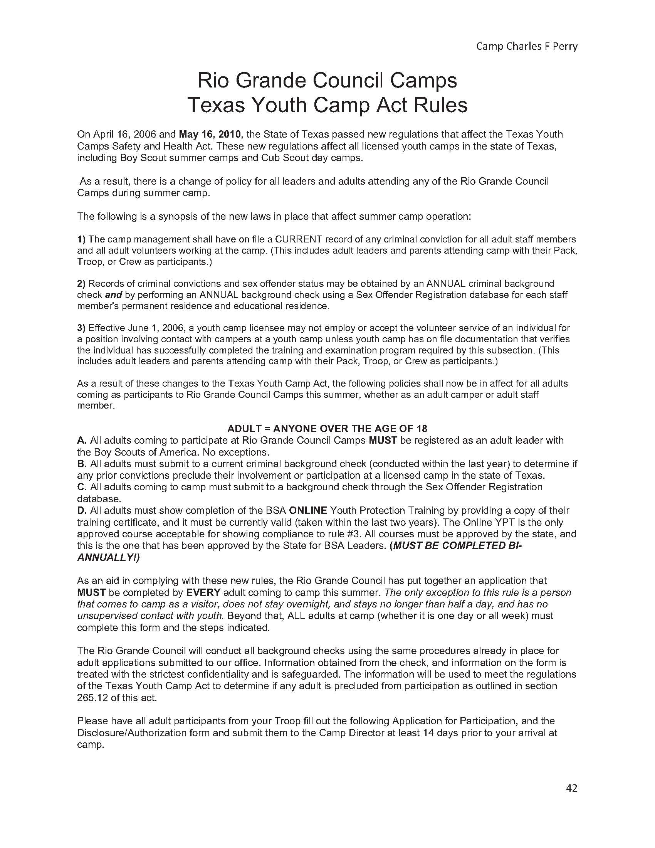

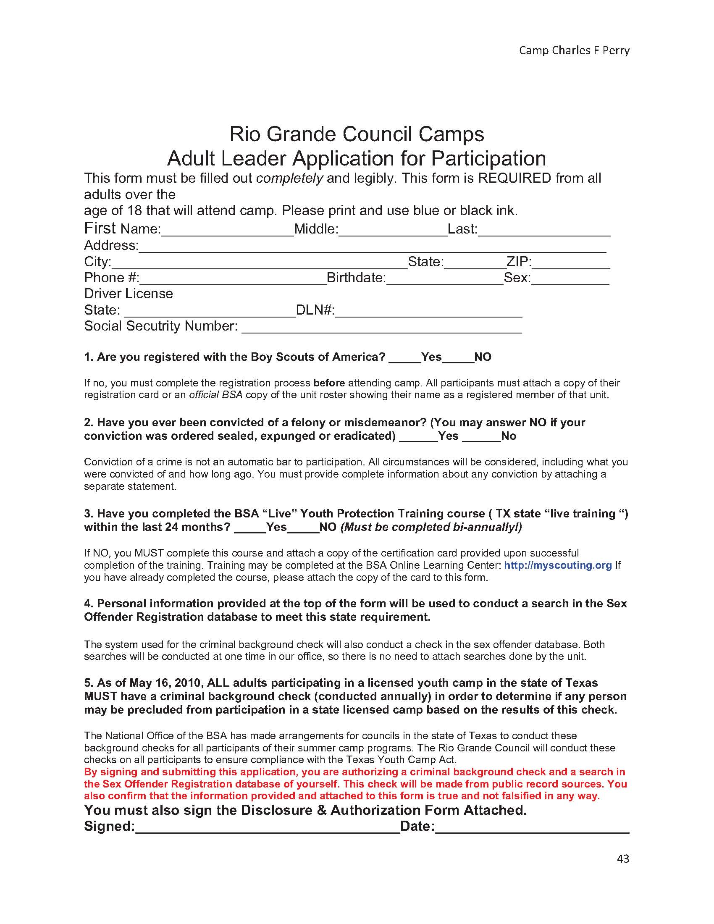**DECEMBER 15, 2021 - DEADLINE TO SUBMIT TO COUNCIL OFFICE**

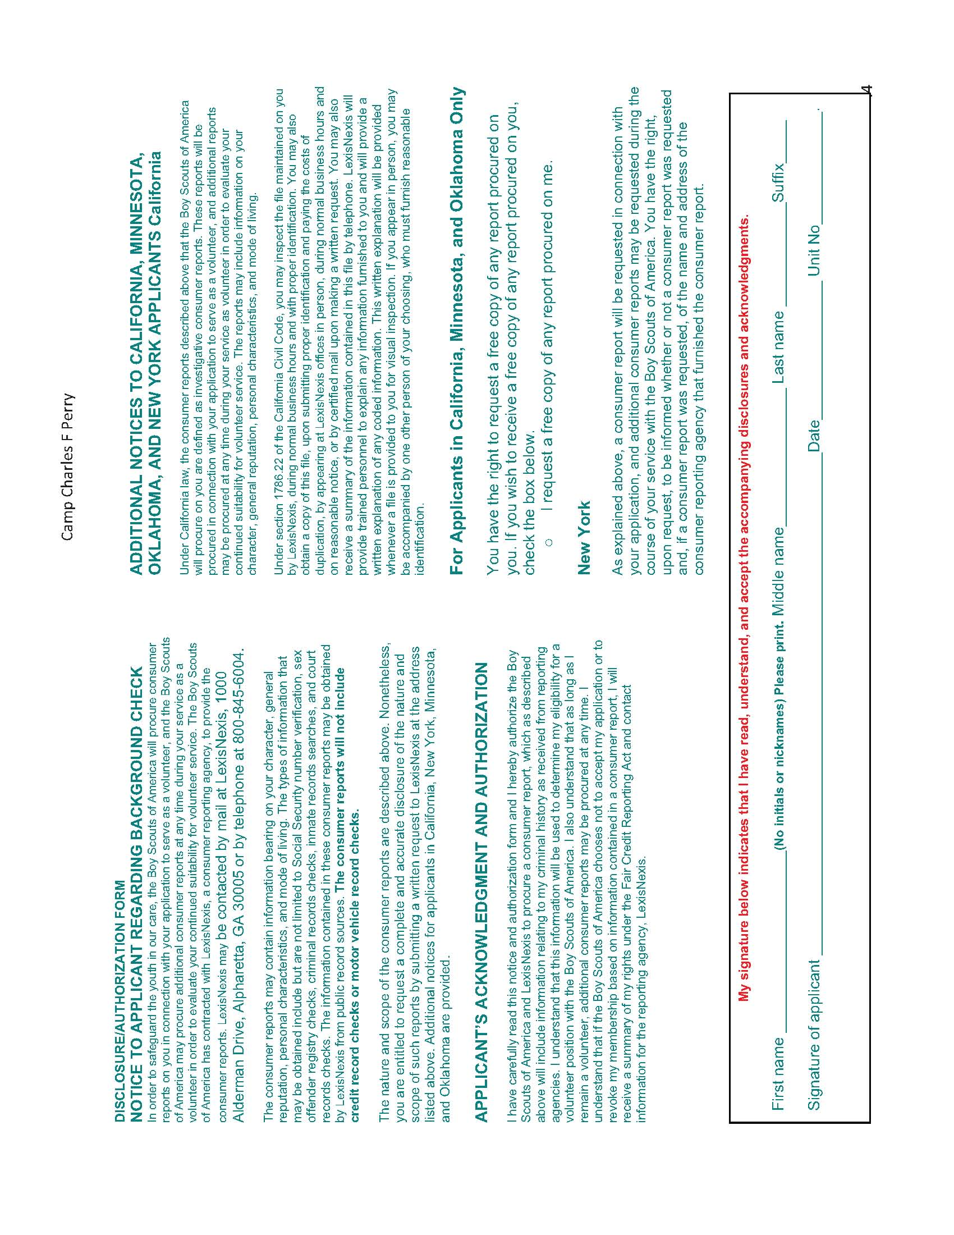**DECEMBER 15, 2019 - DEADLINE TO SUBMIT TO COUNCIL OFFICE**

**PROCEDURE FOR**

**“NO SHOWS’**

**AT REGISTRATION**

For compliance in the protection of all campers pre-registered to attend Camp Perry the following procedures will be followed:

* Scoutmasters are asked to verify any “no shows” from their attendance roster turned in prior to arrival at camp. This may be done at a Leader’s Meeting or via the e-mail.
* If there are “no shows” the Scoutmaster must provide written explanation of “no shows” from information he has concerning the Scout.
* If the Scoutmaster is unaware he must investigate the reason for the “no show(s)” and then prepare a written explanation within 24 hours and submit to the Camp Director.

**PROCEDURES FOR INTRUSION OF UNAUTHORIZED PERSONS**

1. All authorized participants and authorized persons shall be identified as follows:

Campers –wristbands

Staff –wristbands

Leaders –wristbands

Visitors –wristbands

Vendors/other external workers - company uniform – wristbands

1. When a person does not fit the above,

Staff members are to ask:

**“Excuse me, can I help you?”**

Respond to their response by asking:

**“Would you like me to show you to the office so that you can register?”**

**If the person cooperates** - you to walk them to the Office, do so and the office staff will process the visitor. Thank them and tell them “I hope you enjoy your visit to our camp, the office staff will take care of you”.

**If the person does NOT cooperate** -

* + - Note person’s physical features
    - Note their attire
    - Note which direction they are going or remember if they tell you where they are going.
    - Report to the office or to the nearest ADULT (with a BLUE OR RED bracelet) and inform them that someone is on camp without a wristband and then go to the office and report what you saw and heard.

**ADULT** **APPRAISAL SHEET**

Item Excellent Good Satisfactory Unsatisfactory

|  |
| --- |
| Staff Services |
| Food Services |
| Program Helps |
| Health and Sanitation |

Remarks on any of the above items:

1.

2.

3.

4.

5.

What did you enjoy most about camp?

1.

2.

3.

4.

5.

What suggestions do you have to help improve before camp?

1.

2.

3.

4.

5.

**Youth Appraisal Sheet**

Item Excellent Good Satisfactory Unsatisfactory

|  |
| --- |
| Staff Services |
| Food Services |
| Program Helps |
| Health and Sanitation |

Remarks on any of the above items:

1.

2.

3.

4.

5.

What did you enjoy most about camp?

1.

2.

3.

4.

5.

What suggestions do you have to help improve before camp?

1.

2.

3.

4.

5.

**NOTES**

**NOTES**