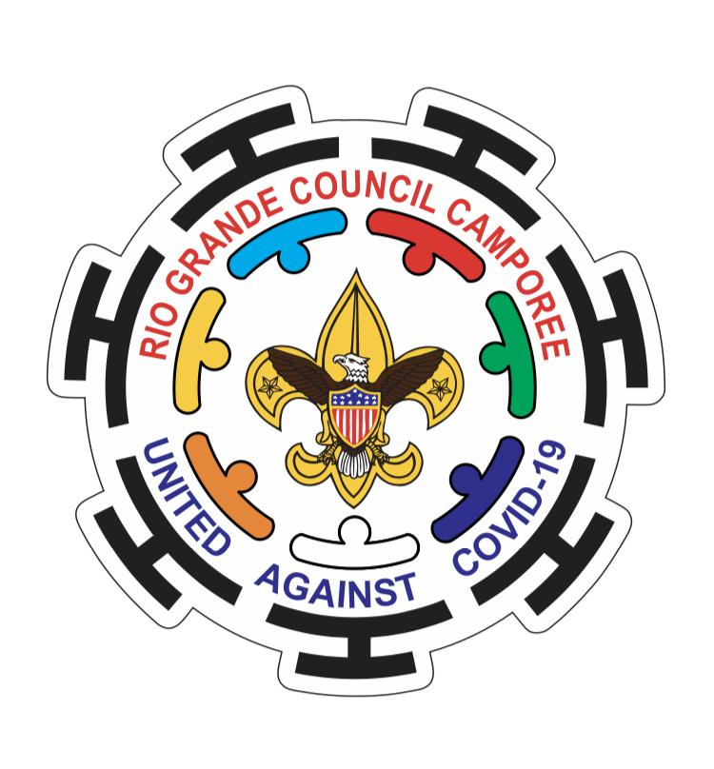
Rio Grande Council
Virtual Camporee
Leaders Guide 2021

Dear Scouts and Leaders,
The Rio Grande Council invites you to participate in the Virtual Camporee of 2021, which will take place on April 24th and 25th, 2021. This event is open to, Troops, Crews, Ships and Posts. This is a good opportunity for our Scouts to learning new skills and to complete rank advancements.

Schedule of events for April 24th

08:00 am - 08:30 am Check-In ( Scoutbook required all the time for this event )

08:30 am - 08:45am Flag Ceremony and Welcome (SC 8a)

08:45 am - 09:00 am Flag Folding (T 7a) US Flag required for this session

09:00 am - 09:45 am Knots (T 3a,3b,3c), (SC 2f,2g), (FC 3b) two pieces of string required in this - session

10:00 am - 10:45 am First Aid (T 4a), (SC 6a), (FC 7a,7b) first aid kit bandages and scarf - required for this session

11:00 am - 11:45 am Cooking (T 2b), (SC 2e) ingredients needed for this session. chicken breast or - a burger patty or fish fillet (choose one). onion, bell pepper, pepperoni, - tomato sauce, salt and pepper, aluminum foil.

12:00 pm - 01:00 pm Lunch

01:00 pm - 01:45 pm Lashings (FC 3a, 3c, 3d) materials needed for this session 12 pencils or round - wooden sticks hemp thread

02:00 pm - 02:45 pm Drug Awareness (Conference with City of Harlingen Police Officer)

03:00 pm - 04:00 pm Fire Building (Totin Chip)

Schedule of events for July 25th

09:00 am - 09:45 Interfaith Service and farewell

The dynamics of the event will be as follows.

This is a virtual camp that will be carried out via Zoom, and it will have 4 live broadcasts.

The first live broadcast will begin at 8:00 am with the Check in and will end at 12:00 pm with first aid. There will be a one-hour break for Lunch.

The second transmission will start at 1:00 pm and will end at 4:00 pm. What will happen in the 15-minute break between class and class? They will have the opportunity to enjoy songs and performances of scouts from other troops! In these first two sessions some scouts will be able to interact with the presenters by asking questions or comments.

The third transmission will be from 9:00 pm to 9:45 pm with our campfire. For the campfire program the units may participate with a song or performance that does not exceed 5 minutes.

Units interested in participating in the campfire will have to register their song or performance by sending an email to l.albertomiranda@hotmaill.com with the name of the performance or song and unit number.

Registered songs or performances must adhere to Scouting's standards and rules!
The fourth and last session will be on Sunday, April 25th from 9:00 am to 9:45 am.

The cost of this virtual event will be $18.00 dollars and it includes full access to the four virtual sessions.

For any questions or comments please contact l.albertomiranda@hotmail.com

Thank you very much, I hope to see you soon!

Register now.

http://www.riograndecouncil.org/registration/calendardetail.aspx?activitykey=2747432&orgkey=2275&ReturnURL=//www.riograndecouncil.org/app/calendar/month/2275/2021-04-01/-1/0/

Luis A. Miranda Ernest Espinoza
Event Chair. Staff Advisor.

